Nicholas Skinner

CS 491

Fall 2019

Assignment 5: Particle System

Screenshot:

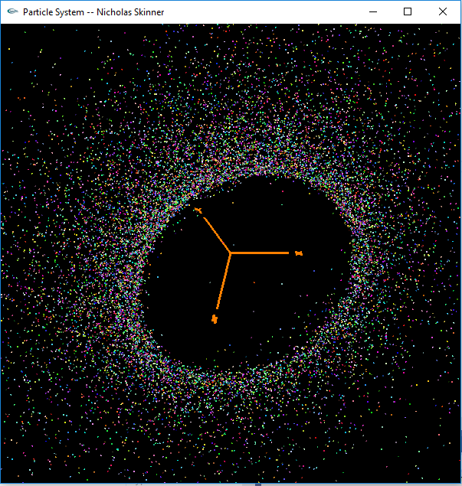

Video Link: <https://media.oregonstate.edu/media/0_a02eurve>

A few of my random components:

Random start (location within the ring)

Random color

Random velocity